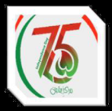

Dated: 19-06-2023
EVALUATION REPORT

(As Per PPRA Rule 35 of PP Rules, 2004)

01 | Name of Procuring Agency | Karachi Port Trust
02 | Method of Procuring | SSTE ( Single Stage One Envelope)
03 | Title of Procurement | UPLIFTMENT OF EXTERIOR FACE AND OTHER ALLIED WORKS OF KPT RESIDENTIAL BUILDING VIZ. APARTMENT TOWER BATH ISLAND.
04 | Tender Inquiry No | E/N-2(60)/
05 | PPRA Ref No. (TSE) | TS510154E
06 | Date & Time of Bid Closing | 25-05-2023 at 10:30 Hours
07 | Date & Time of Bid Opening | 25-05-2023 at 11:00 Hours
08 | No. of Bid Received | 03 Nos.
09 | Criteria of Bid Evaluation | Lowest Evaluated Bid
10 | Detail of Bid (s) Evaluation | Given Below

S.  No | Name of Bidder | Status |  | Evaluated Cost | Rule / Regulation /  SBD / Policy / Basis of Rejection/Acceptance  as per Rule 35 of PP Rules,2004
S.  No | Name of Bidder | Technical | Financial | Evaluated Cost
1. | M/s. AJJ Enterprises | - | - | Rs.2,065,755.83 | 1st Lowest Bidder
2. | M/s. Pirbhoy & Sons | - | - | Rs. 2,779,969.50 | 2nd Lowest Bidder
 | M/s. Musheer & Sons | - | - | Rs. 2,908,242.01 | 3rd Lowest Bidder

Evaluated Bidder: M/s. AJJ Enterprises

Signature | 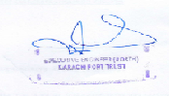
Official Stamp

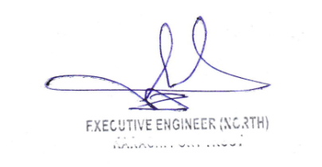

Head Office. Eduljee Dinshaw Road, I. I. Chundrigar Road, Karachi Phone # 99214530-40 Fax #99214329-30

